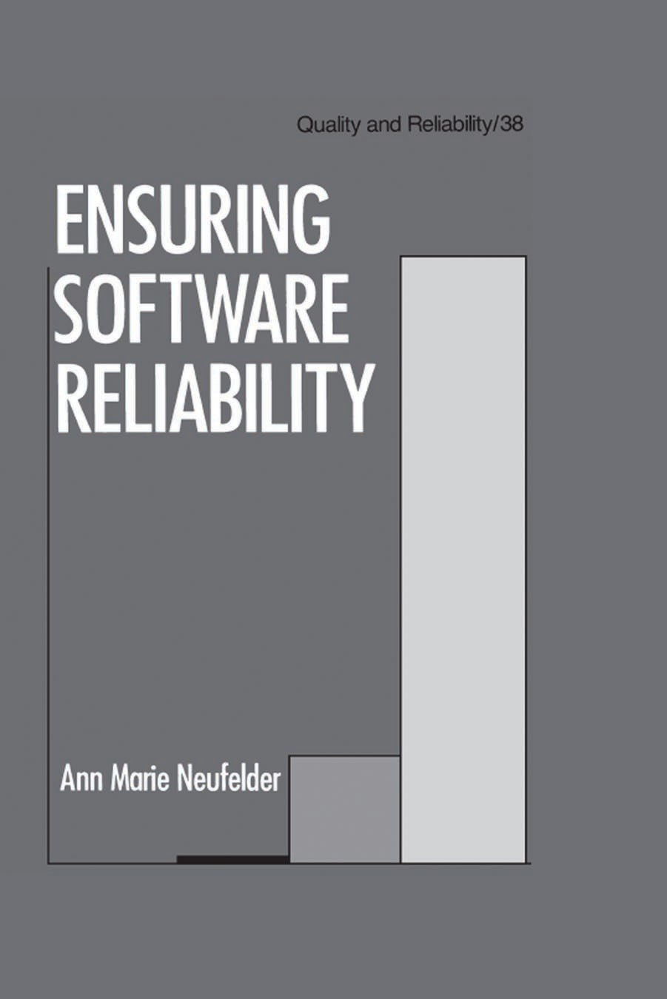

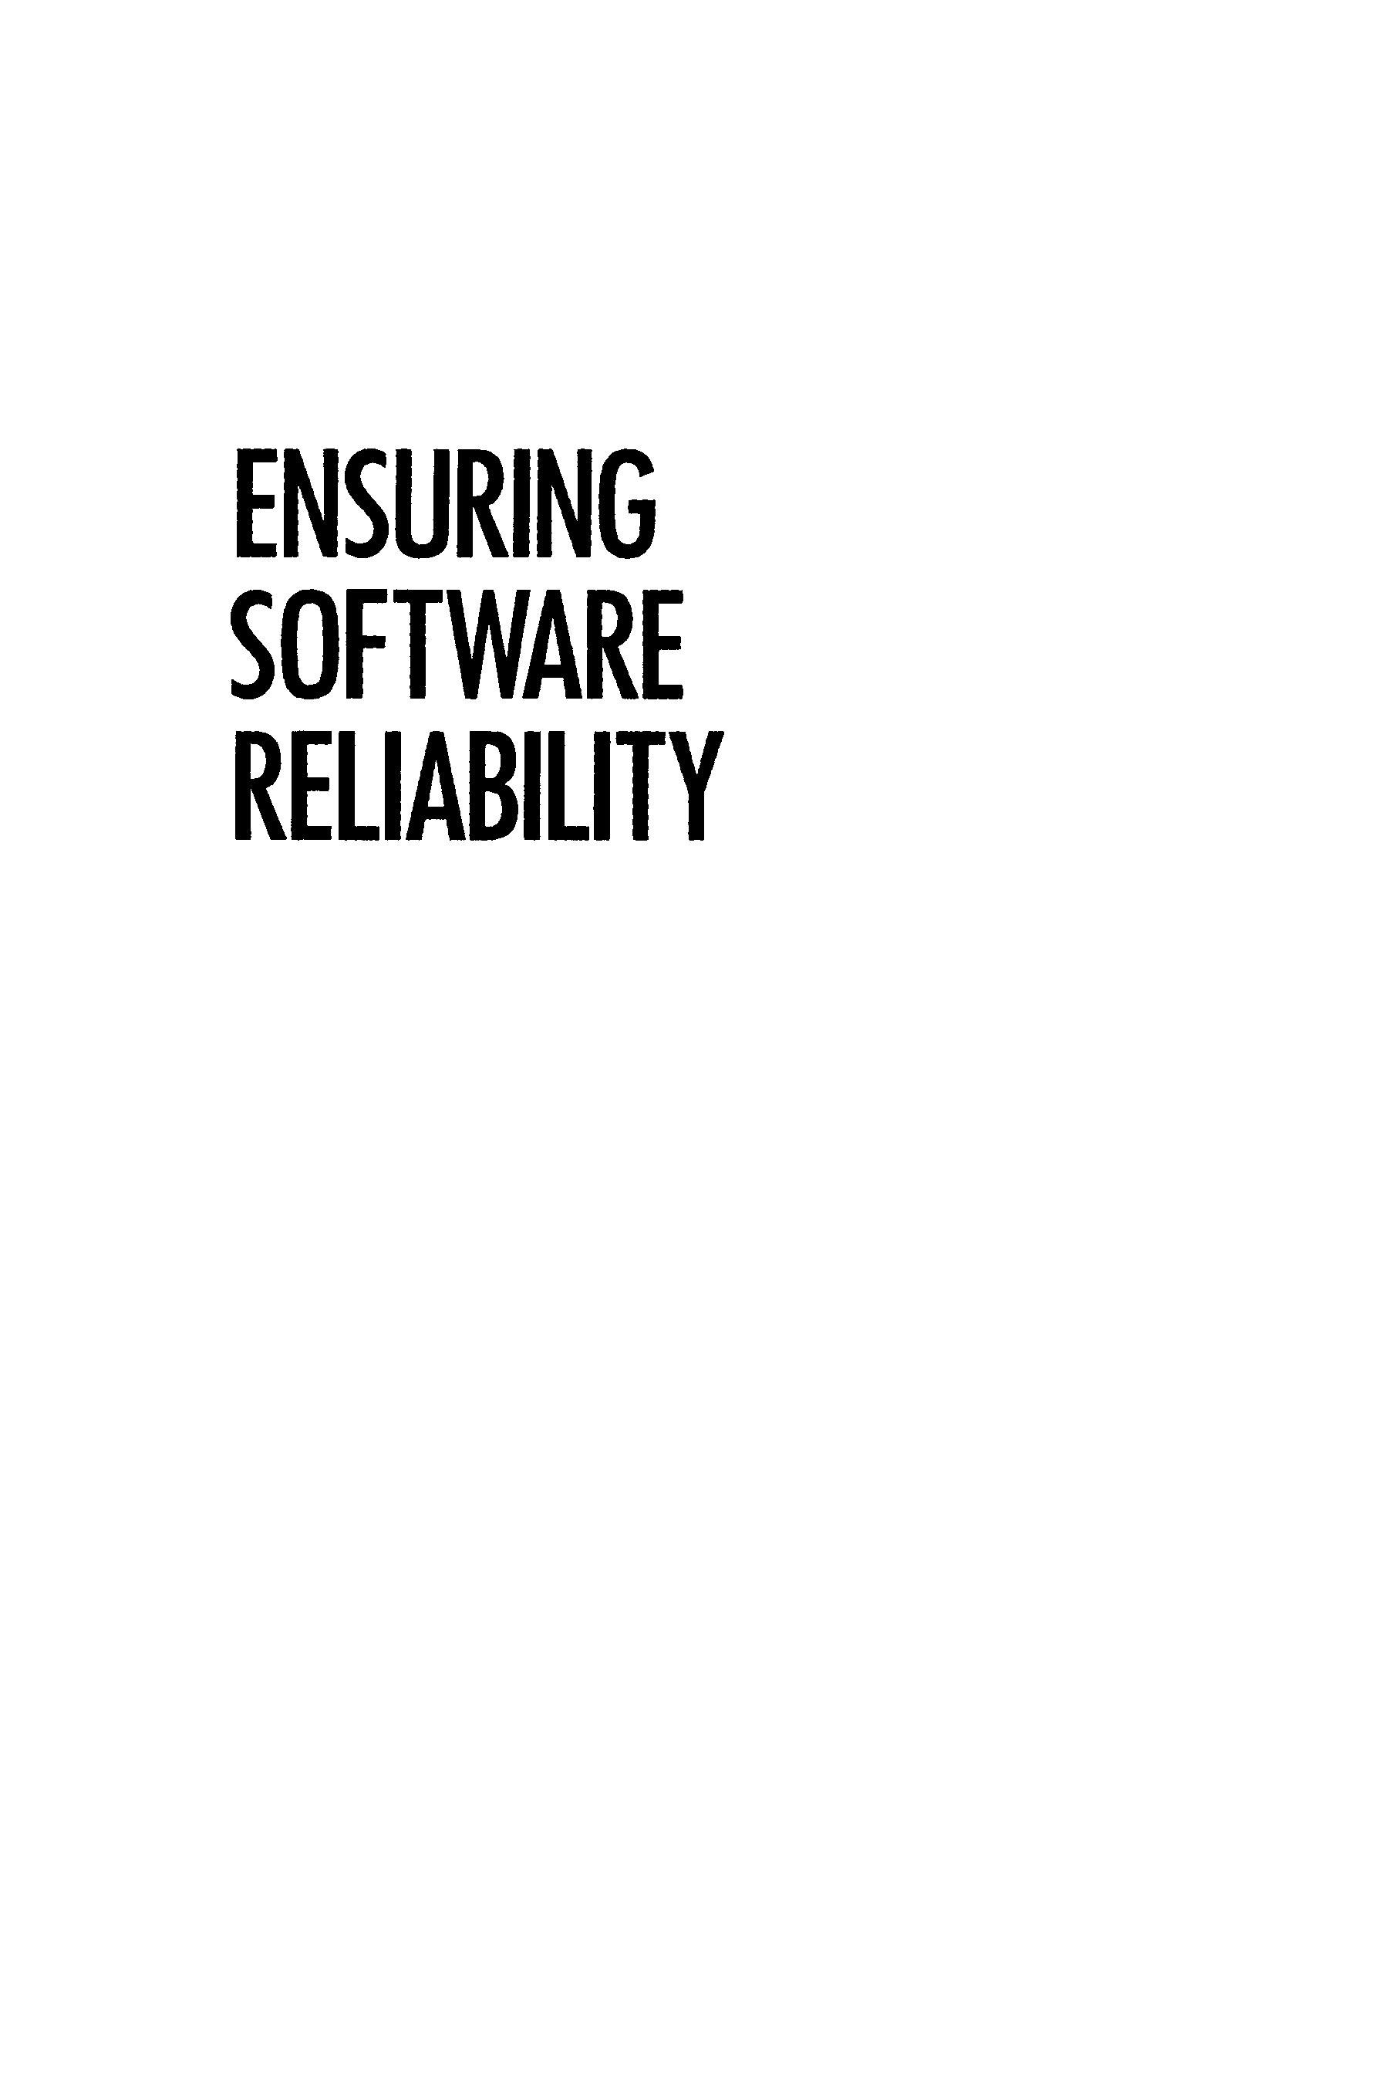

# ENSURING SOFTWARE RELIABILITY

#### QUALITY AND RELIABILITY

***A Series Edited by***

EDWARD G. SCHILLING

***Coordinating Editor***

##### Center for Quality and Applied Statistics Rochester Institute of Technology Rochester, New York

**W. GROVER BARNARD *Associate Editor for Human Factors***

##### Vita Mix Corporation Cleveland, Ohio

**RICHARD S. BINGHAM, JR.**

***Associate Editorfor Quality Management* Consultant Brooksville, Florida**

##### LARRY RABINOWITZ

***Associate Editor for Statistical Methods***

##### College of William and Mary

**Williamsburg, Virginia**

##### THOMAS WITT

***Associate Editorfor Statistical Quality Control***

##### Rochester Institute of Technology

**Rochester, New York**

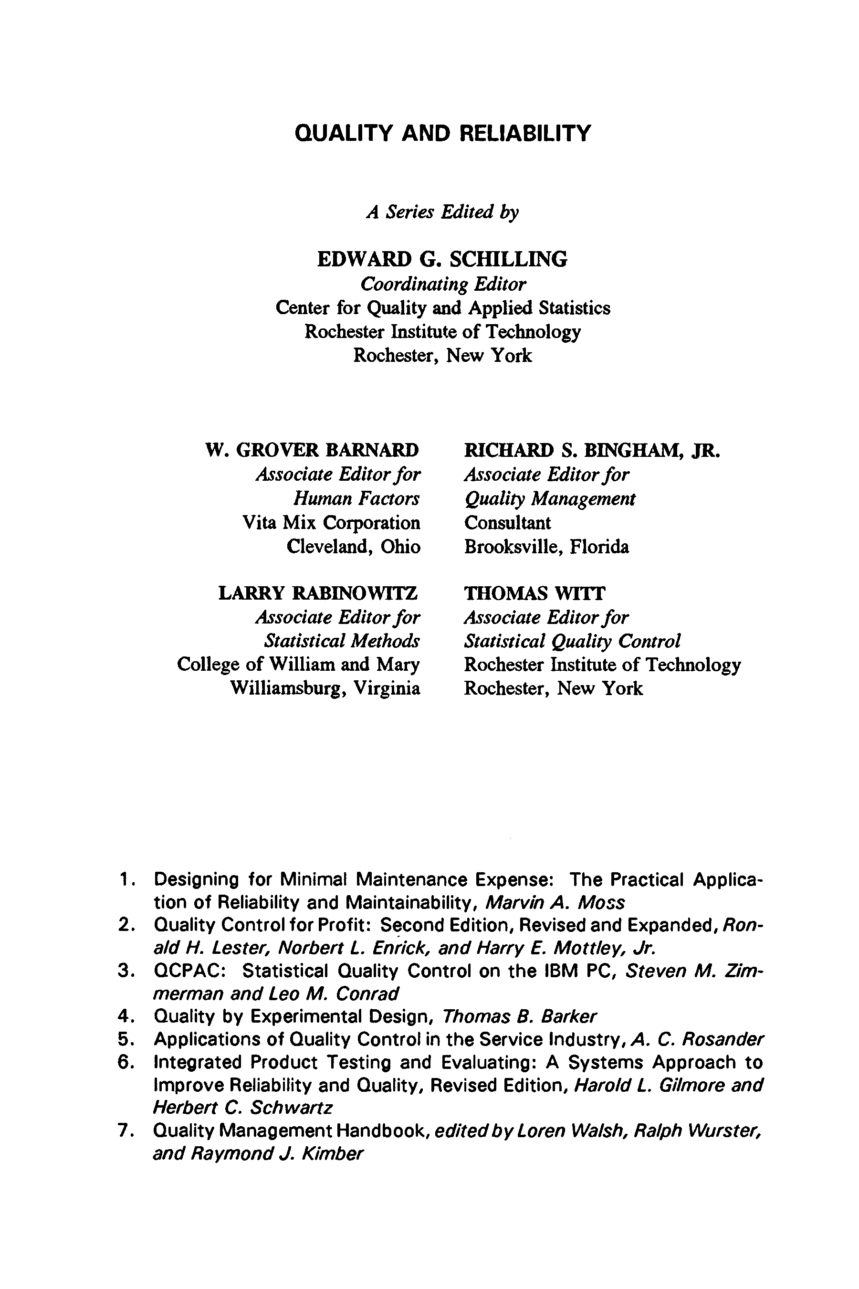

1. **Designing for Minimal Maintenance Expense: The Practical Applica­ tion of Reliability and Maintainability, *Marvin A. Moss***
2. **Quality Control for Profit: Second Edition, Revised and Expanded, *Ron-***

***aid H. Lester, Norbert L. Enrick, and Harry E. Mottley, Jr.***

1. **QCPAC: Statistical Quality Control on the IBM PC, *Steven M. Zim­ merman and Leo M. Conrad***
2. **. Quality by Experimental Design, *Thomas B. Barker***
3. **Applications of Quality Control in the Service Industry, *A. C. Rosander* 6. Integrated Product Testing and Evaluating: A Systems Approach to Improve Reliability and Quality, Revised Edition, *Harold L. Gilmore and***

***Herbert C. Schwartz***

1. **Quality Management Handbook, *edited by Loren Walsh, Ralph Wurster, and Raymond J. Kimber***
2.** 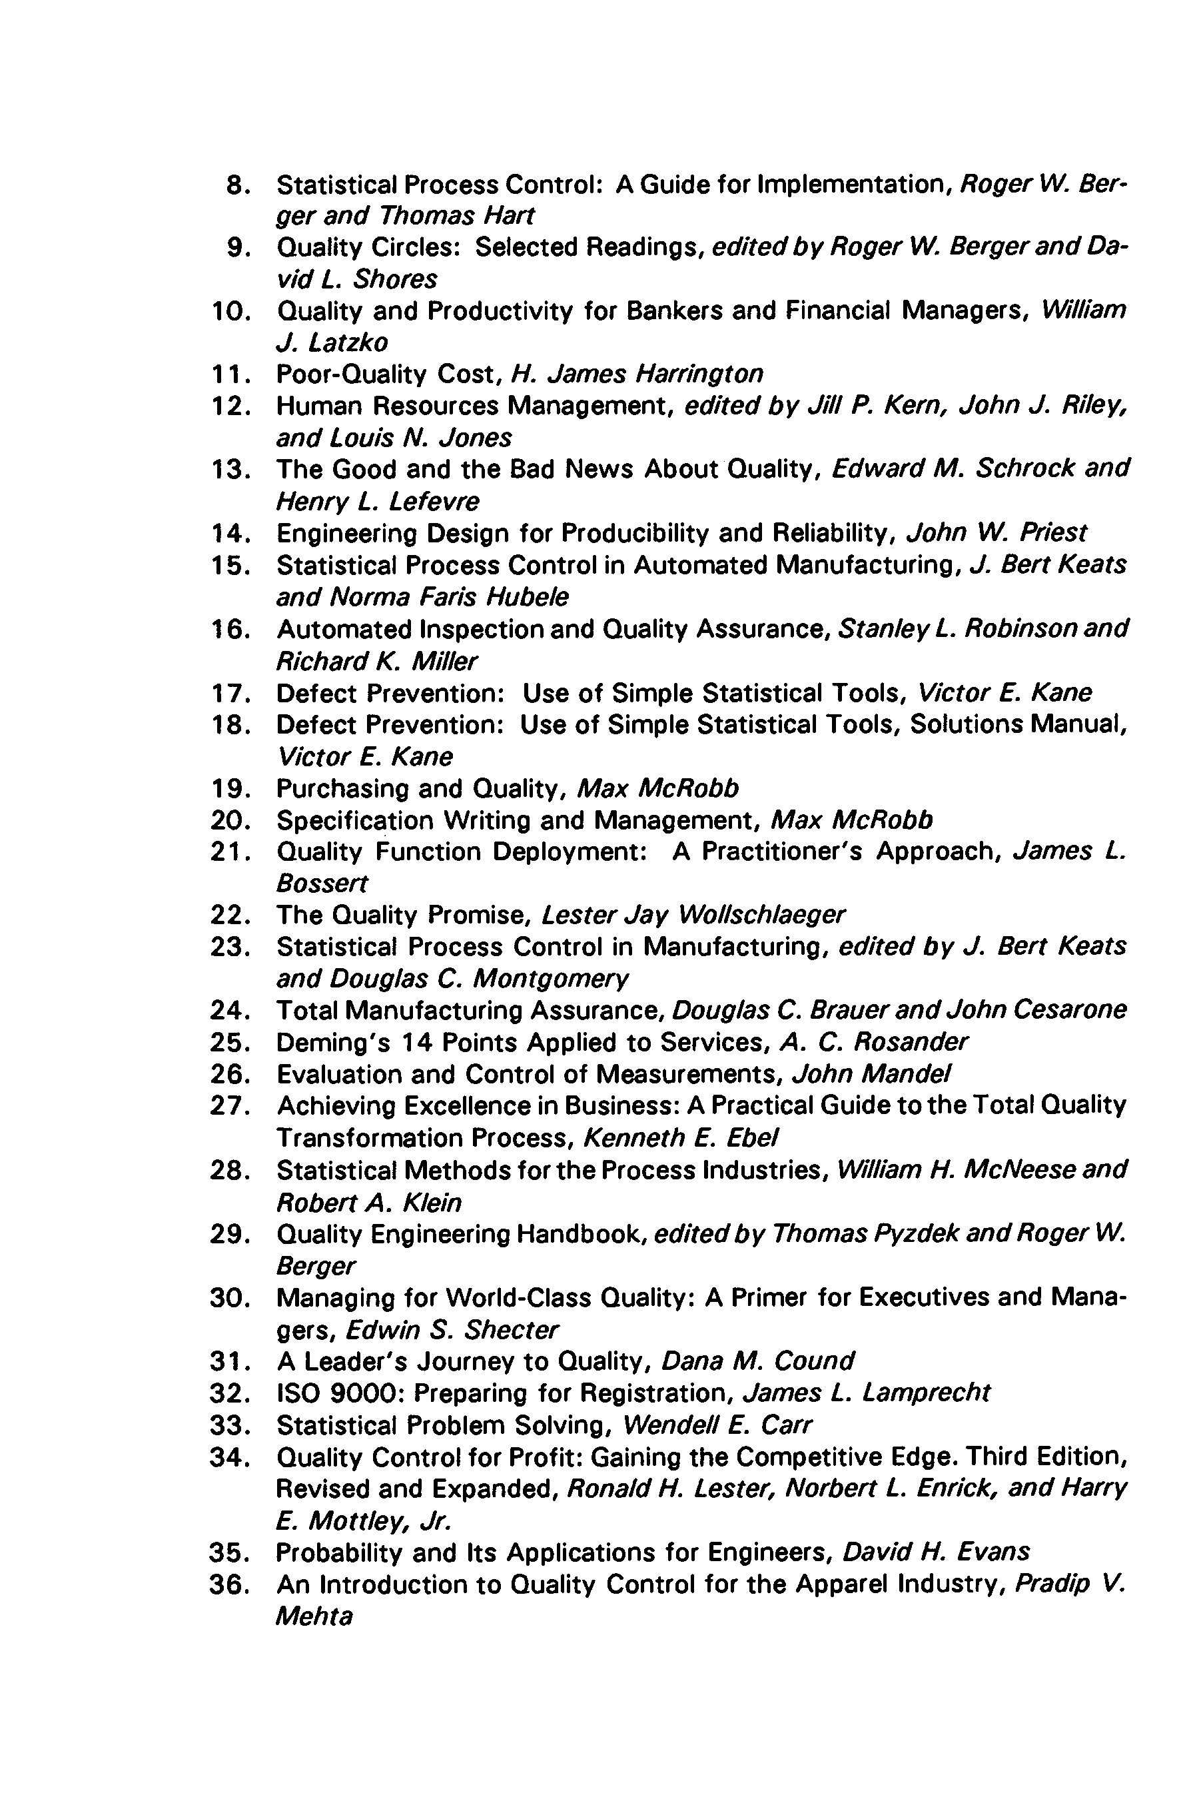. Statistical Process Control: A Guide for Implementation, *Roger W. Ber­ ger and Thomas Hart***
3. **Quality Circles: Selected Readings, *edited by Roger W. Berger and Da­ vid L. Shores***
4. **Quality and Productivity for Bankers and Financial Managers, *William***

***J. Latzko***

1. **Poor-Quality Cost, *H. James Harrington***
2. **Human Resources Management, *edited by Jill P. Kern, John J. Riley, and Louis N. Jones***
3. **The Good and the Bad News About Quality, *Edward M. Schrock and Henry L. Lefevre***
4. **Engineering Design for Producibility and Reliability, *John W. Priest***
5. **Statistical Process Control in Automated Manufacturing, *J. Bert Keats and Norma Paris Hubeie***
6. **Automated Inspection and Quality Assurance, *Stanley L. Robinson and Richard K. Miller***
7. **Defect Prevention: Use of Simple Statistical Tools, *Victor E. Kane***
8. **Defect Prevention: Use of Simple Statistical Tools, Solutions Manual,**

***Victor E. Kane***

1. **Purchasing and Quality, *Max McRobb***
2. **. Specification Writing and Management, *Max McRobb***
3. **. Quality Function Deployment: A Practitioner's Approach, *James L. Bossert***
4. **. The Quality Promise, *Lester Jay Wollschlaeger***
5. **. Statistical Process Control in Manufacturing, *edited by J. Bert Keats and Douglas C. Montgomery***
6. **. Total Manufacturing Assurance, *Douglas C. Brauer and John Cesarone***
7. **. Deming's 14 Points Applied to Services, *A. C. Rosander***
8. **. Evaluation and Control of Measurements, *John Mande!***
9. **. Achieving Excellence in Business: A Practical Guide to the Total Quality Transformation Process, *Kenneth E. Ebel***
10. **. Statistical Methods for the Process Industries, *William H. McNeese and Robert A. Klein***
11. **. Quality Engineering Handbook, *edited by Thomas Pyzdek and Roger W.***

***Berger***

1. **. Managing for World-Class Quality: A Primer for Executives and Mana­ gers, *Edwin S. Shecter***

**3 1 . A Leader's Journey to Quality, *Dana M. Cound***

**32 . ISO 9000 : Preparing for Registration, *James L. Lamprecht***

**3 3 . Statistical Problem Solving, *Wendell E. Carr***

1. **. Quality Control for Profit: Gaining the Competitive Edge. Third Edition, Revised and Expanded, *Ronald H. Lester, Norbert L. Enrick, and Harry***

***E. Mottley, Jr.***

1. **. Probability and Its Applications for Engineers, *David H. Evans***
2. **. An Introduction to Quality Control for the Apparel Industry, *Pradip V. Mehta***
3.** 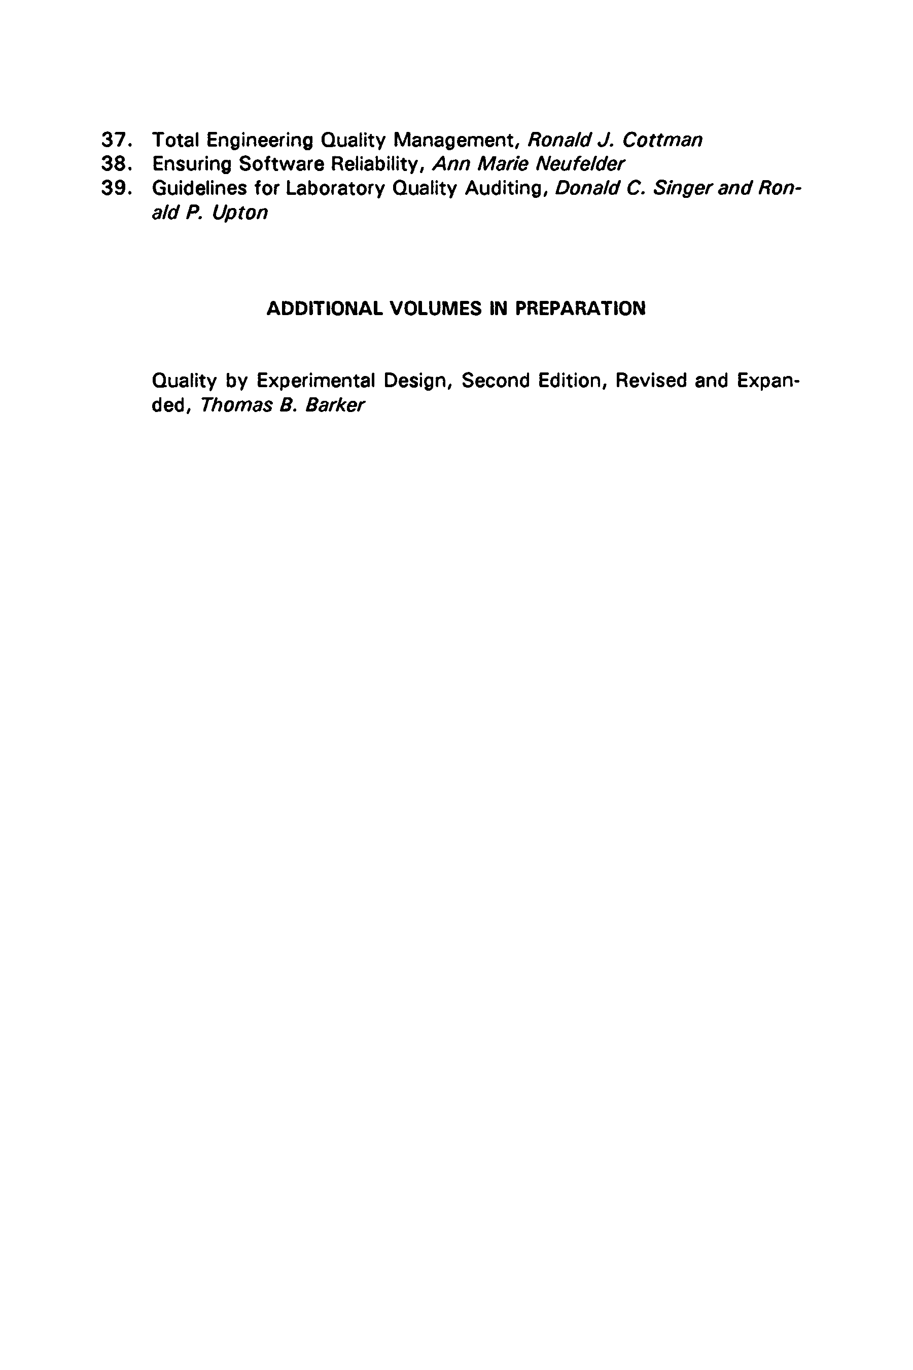. Total Engineering Quality Management, *Ronald J. Cottman***
4. **. Ensuring Software Reliability, *Ann Marie Neufelder***
5. **. Guidelines for Laboratory Quality Auditing, *Donald C. Singer and Ron­ ald P. Upton***

**ADDITIONAL VOLUMES IN PREPARATION**

**Quality by Experimental Design, Second Edition, Revised and Expan­ ded, *Thomas B. Barker***

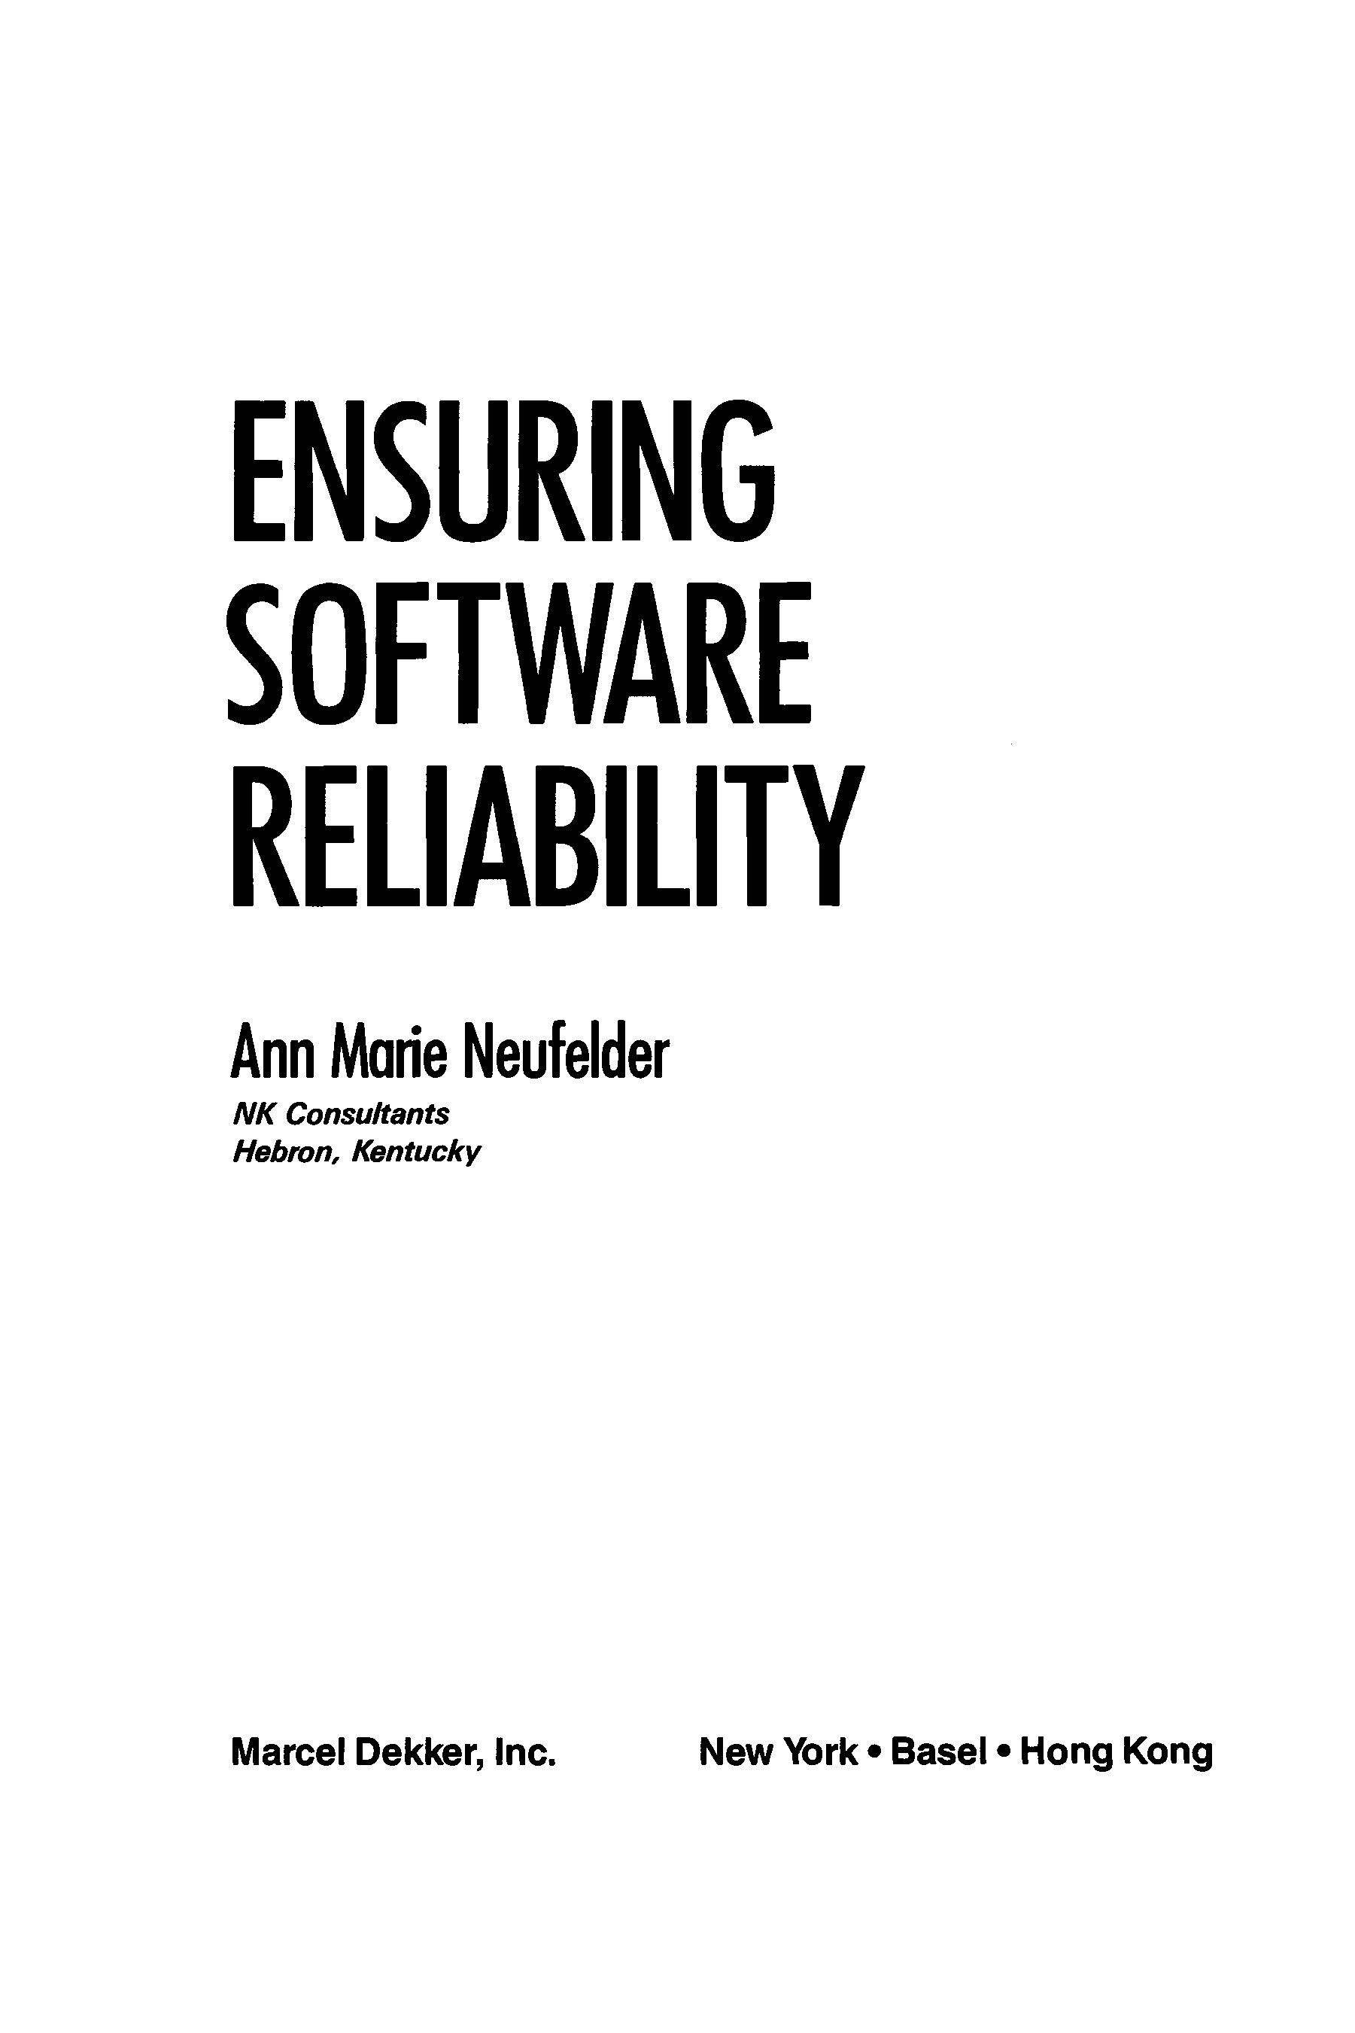

**ENSURING SOFTWARE RELIABILITY**

**Ann Marie Neufelder**

***N K Consultants Hebron, Kentucky***

#### Marcel Dekker, Inc. New York • Basel • Hong Kong

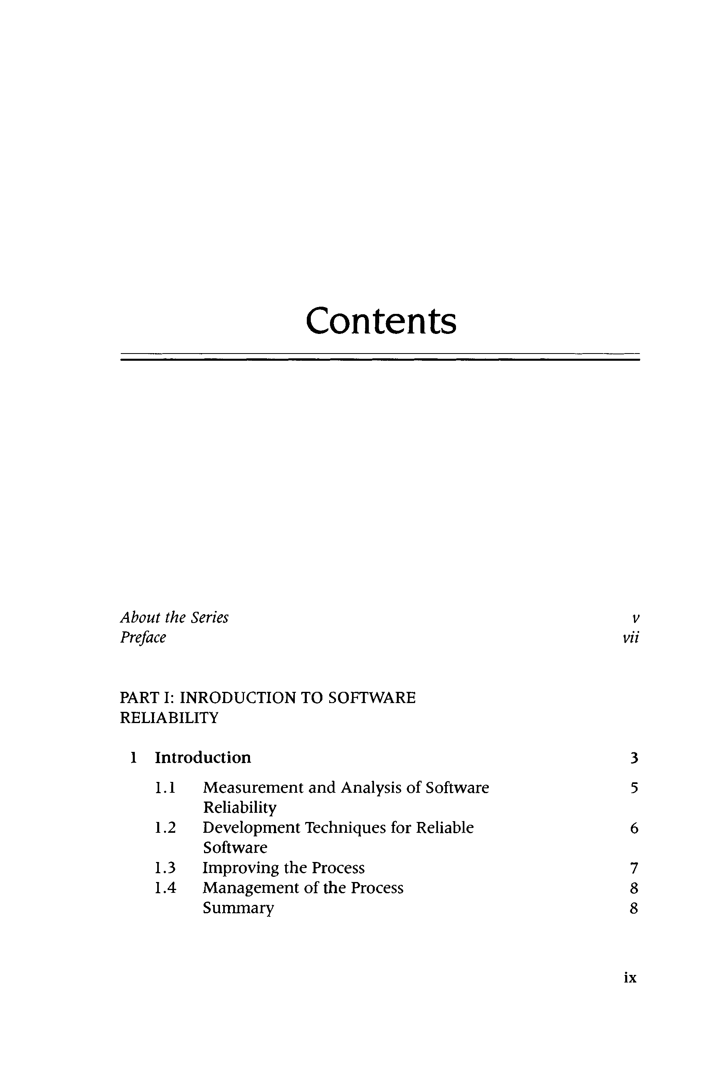Contents

*About the Series v*

Preface vii

PART I: INRODUCTION TO SOFTWARE RELIABILITY

1. Introduction 3
   1. M easurem ent and Analysis of Software Reliability
   2. Development Techniques for Reliable Software
   3. Improving the Process
   4. M anagem ent of the Process Summary

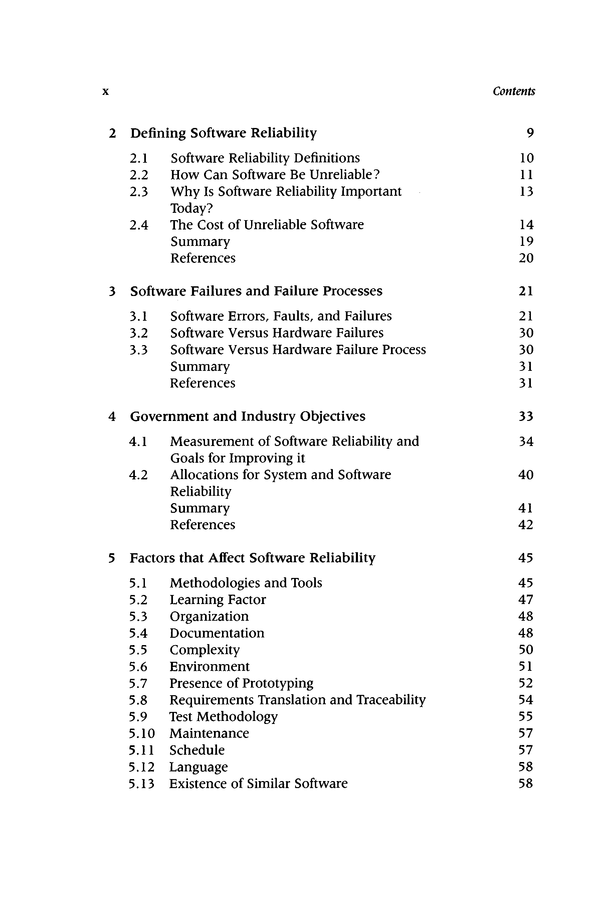**X** *Contents*

##### Defining Software Reliability 9

* 1. Software Reliability Definitions 10
  2. How Can Software Be Unreliable? 11
  3. W hy Is Software Reliability Im portant 13

Today?

* 1. The Cost of Unreliable Software 14

Summary 19

References 20

##### Software Failures and Failure Processes 2 1

* 1. Software Errors, Faults, and Failures 21
  2. Software Versus Hardware Failures 30
  3. Software Versus Hardware Failure Process 30

Summary 31

References 31

##### Government and Industry Objectives 33

* 1. M easurem ent of Software Reliability and 34

Goals for Improving it

* 1. Allocations for System and Software 40

Reliability

Summary 41

References 42

##### Factors that Affect Software Reliability 45

* 1. M ethodologies and Tools 45
  2. Learning Factor 47
  3. Organization 48
  4. Documentation 48
  5. Complexity 50
  6. Environm ent 51
  7. Presence of Prototyping 52
  8. Requirements Translation and Traceability 54
  9. Test Methodology 55
  10. M aintenance 57
  11. Schedule 57
  12. Language 58
  13. Existence of Similar Software 58

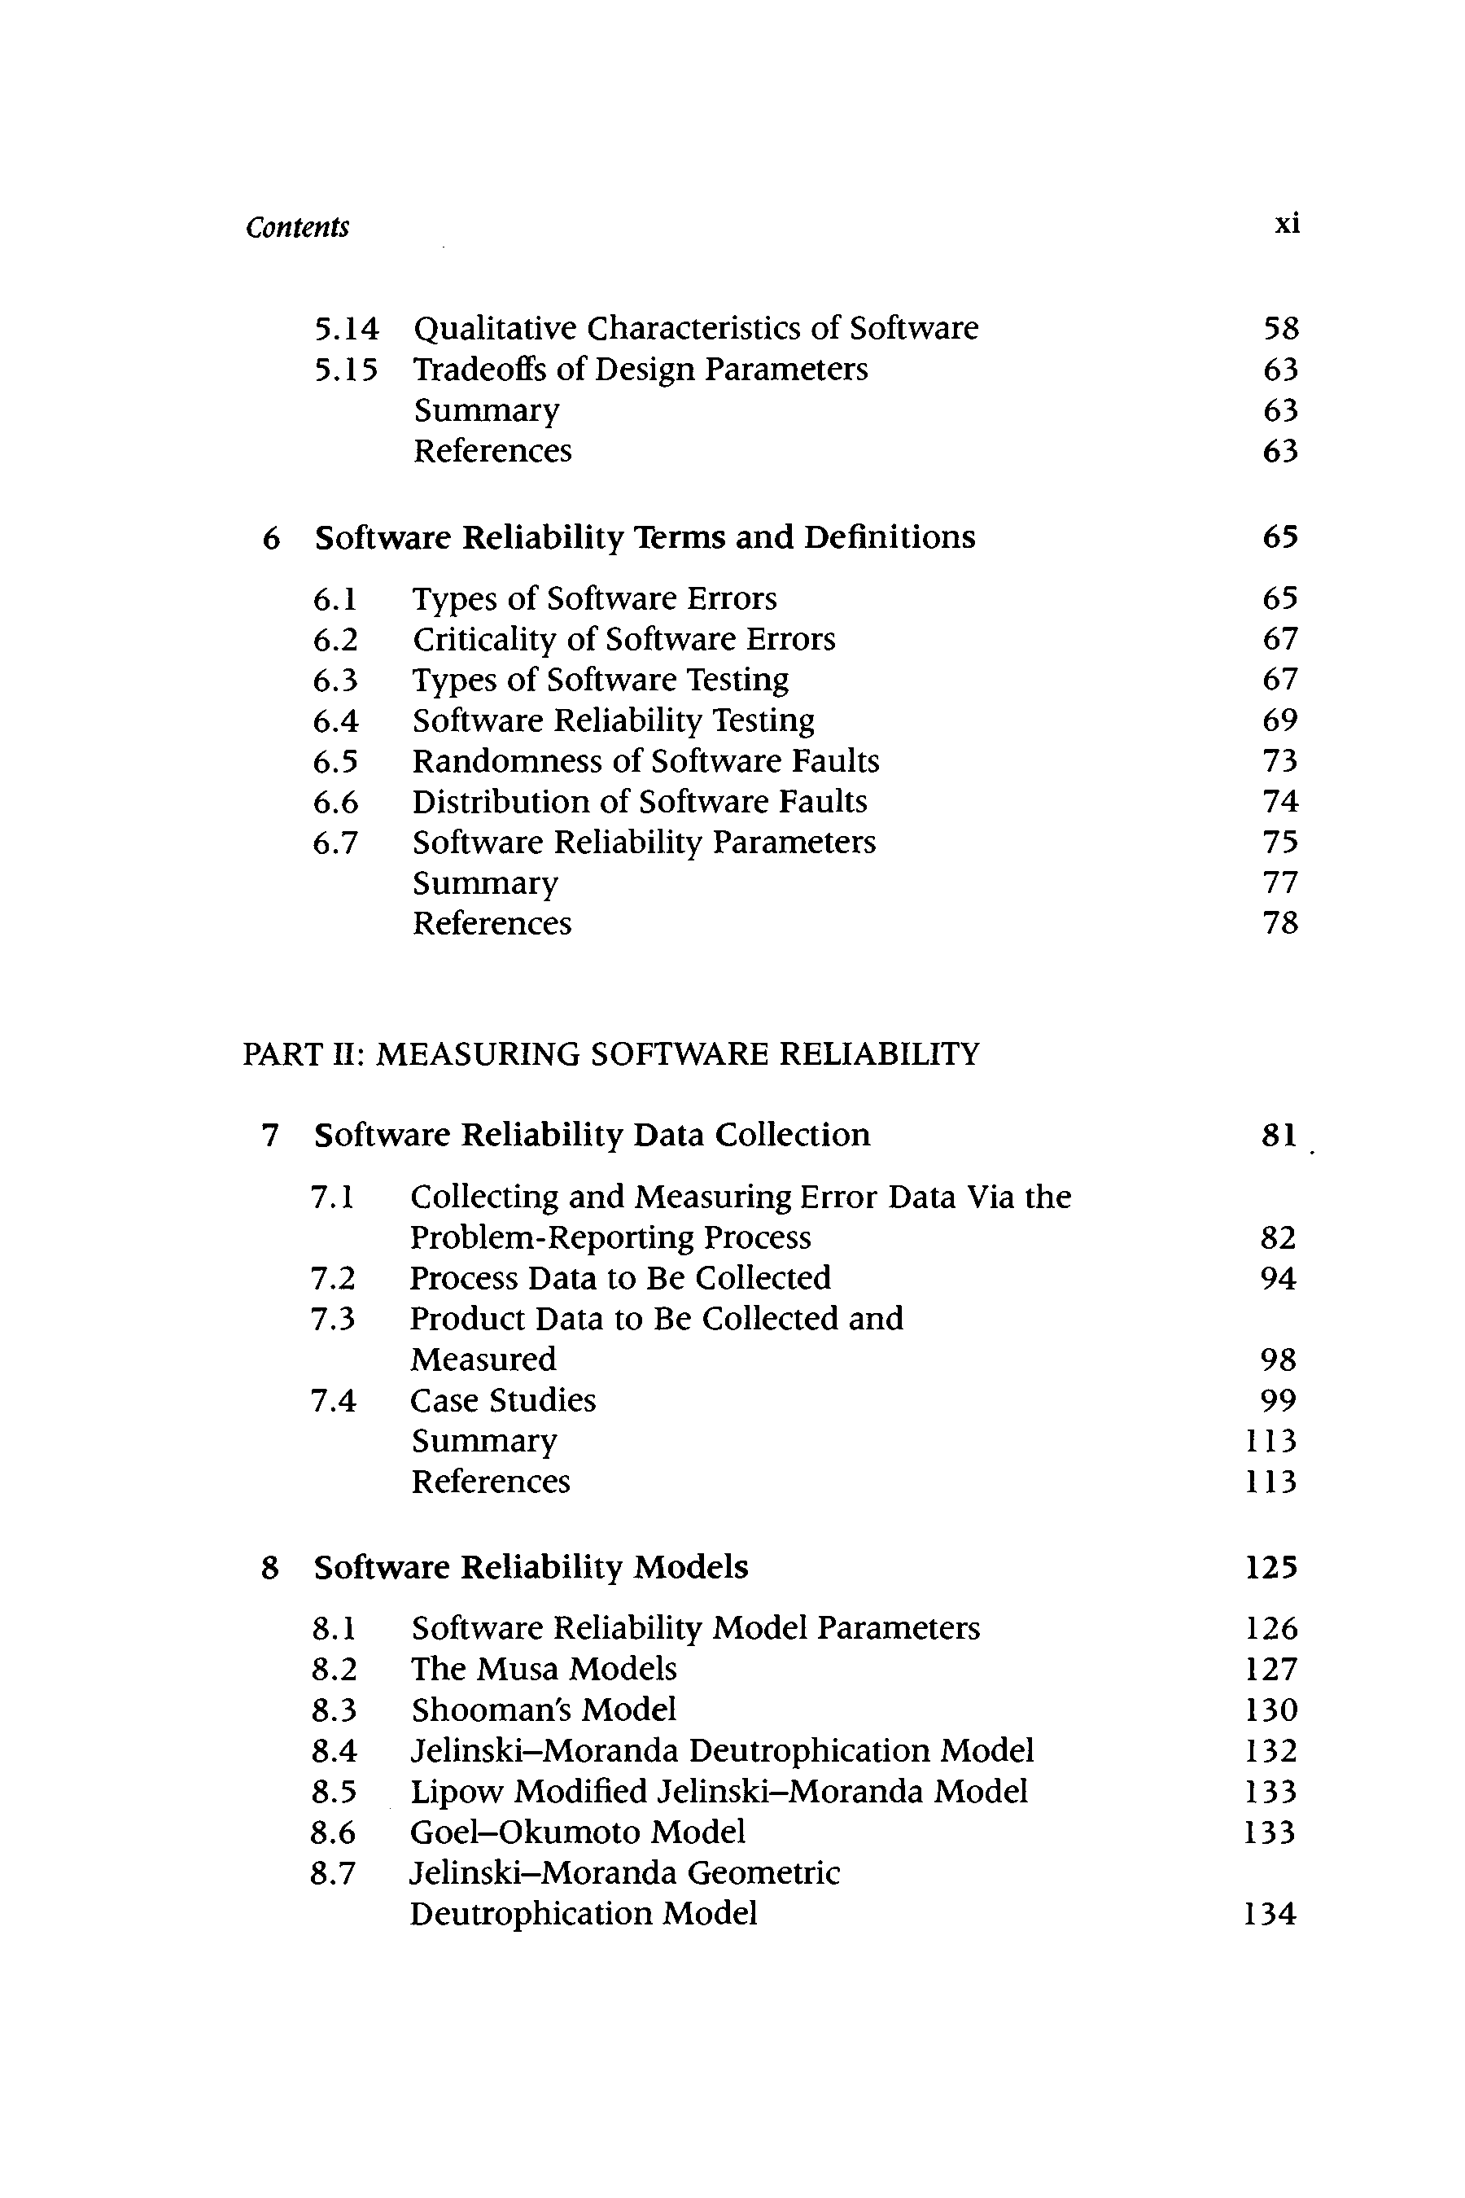*Contents* xi

* 1. Qualitative Characteristics of Software 58
  2. Tradeoffs of Design Parameters 63

Summary 63

References 63

##### Software Reliability Terms and Definitions 65

* 1. Types of Software Errors 65
  2. Criticality of Software Errors 67
  3. Types of Software Testing 67
  4. Software Reliability Testing 69
  5. Randomness of Software Faults 73
  6. Distribution of Software Faults 74
  7. Software Reliability Parameters 75

Summary 77

References 78

PART II: MEASURING SOFTWARE RELIABILITY

##### Software Reliability Data Collection 81

* 1. Collecting and M easuring Error Data Via the

Problem-Reporting Process 82

* 1. Process Data to Be Collected 94
  2. Product Data to Be Collected and

M easured 98

* 1. Case Studies 99

Summary 113

References 113

##### Software Reliability Models 125

* 1. Software Reliability Model Parameters 126
  2. The Musa Models 127
  3. Shooman's Model 130
  4. Jelinski-M oranda Deutrophication Model 132
  5. Lipow Modified Jelinski-M oranda Model 133
  6. G oel-O kum oto Model 133
  7. Jelinski-M oranda Geometric

Deutrophication Model 134

|  |  |  |
| --- | --- | --- |
| xii |  | *Contents* |
| 8.8 | Duane Growth Model | 135 |
| 8.9 | Schick-W olverton Model | 135 |
| 8.10 | Leone Test Coverage Model | 136 |
| 8.11 | Error Seeding Models | 140 |
| 8.12 | Dual Test Group Model | 141 |
| 8.13 | Testing Success Model | 144 |
| 8.14 | Weibull Model | 144 |
| 8.15 | Predictive Models | 146 |
| 8.16 | Case Studies of Reliability Models | 147 |
|  | Summary | 163 |
|  | References | 167 |

PART III: IMPROVING SOFTWARE RELIABILITY

1. 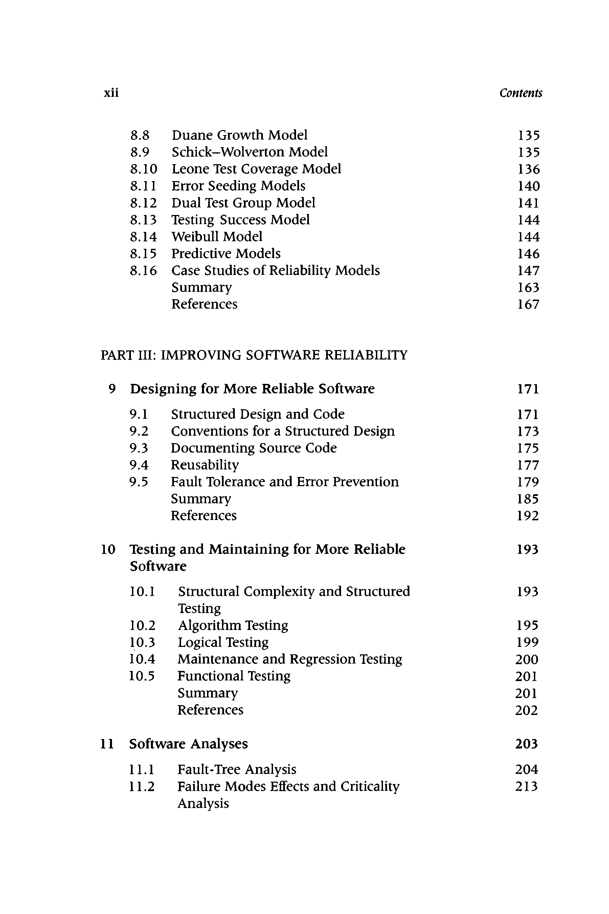D esigning for M ore Reliable Software
   1. Structured Design and Code
   2. Conventions for a Structured Design
   3. Documenting Source Code
   4. Reusability
   5. Fault Tolerance and Error Prevention Summary

References

1. Testing and M aintaining for M ore Reliable Software
   1. Structural Complexity and Structured Testing
   2. Algorithm Testing
   3. Logical Testing
   4. M aintenance and Regression Testing
   5. Functional Testing Summary

References

1. Software A nalyses
   1. Fault-Tree Analysis
   2. Failure Modes Effects and Criticality Analysis

171

171

173

175

177

179

185

192

193

193

195

199

**200**

**201**

**201**

**202**

203

204

213

|  |  |  |
| --- | --- | --- |
| *Contents* |  | xiii |
|  | Summary | 213 |
|  | References | 214 |

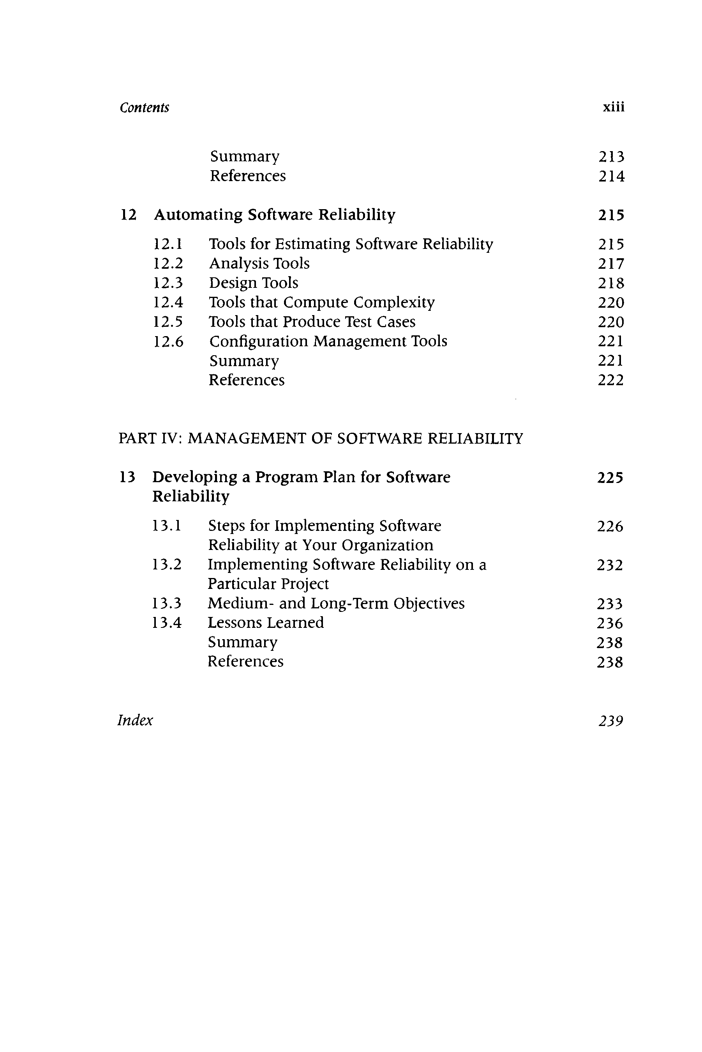

##### Automating Software Reliability 215

* 1. Tools for Estimating Software Reliability 215
  2. Analysis Tools 217
  3. Design Tools 218
  4. Tools that Compute Complexity 220
  5. Tools that Produce Test Cases 220
  6. Configuration M anagem ent Tools 221

Summary 221

References 222

PART IV: MANAGEMENT OF SOFTWARE RELIABILITY

##### Developing a Program Plan for Software 225

##### Reliability

* 1. Steps for Implementing Software 226

Reliability at Your Organization

* 1. Implementing Software Reliability on a 232

Particular Project

* 1. M edium- and Long-Term Objectives 233
  2. Lessons Learned 236

Summary 238

References 238

*Index 23*